**October 13th at 7pm via Zoom DPAC presents**

**Monique Gray Smith**

**Fostering resilience with ourselves and the children in our lives**

In this dynamic and inspiring session, Monique will share her personal journey, offer readings from her various books and provide stories of hope and resilience. She will begin with an overview on how stress & trauma may be impacting us and those we love; including an exploration of what happens in our bodies when we experience trauma. Monique will share her Cultural Resilience model and strategies for weaving aspects of it into your daily life.

Register at [dpacsd75.com/events](http://dpacsd75.com/events)

There is a $5 registration fee.  If you have any parents that would like to attend and are not able to cover the registration, please let me know and we will be able to sponsor them.

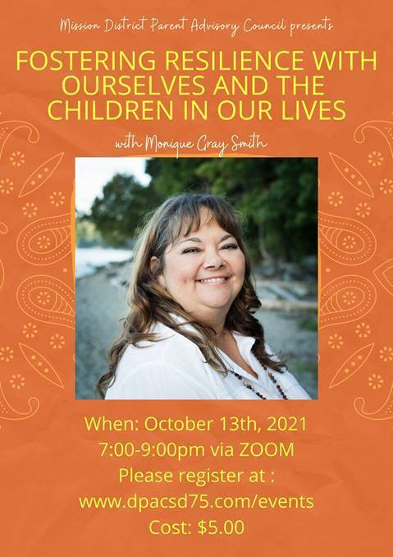

Thank you,

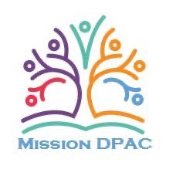

Cheryl Blondin

*Chair, SD75 Mission DPAC*

[*www.dpacsd75.com*](http://www.dpacsd75.com)